

**UNIVERSITY OF PETROLEUM & ENERGY STUDIES**

**Dehradun**

**CONTINOUS INTEGRATION**

**AND**

**CONTINOUS DELIVERY**

**Assignment - 2**

**Name: Shivani Chauhan**

**Course: B. TECH CSE DevOps (2018-22)**

**Roll no.: R171218096**

**Sapid: 500068969**

**Experiment-11**

**Step 1:- Create a maven project using Eclipse IDE with name “Nov20”**

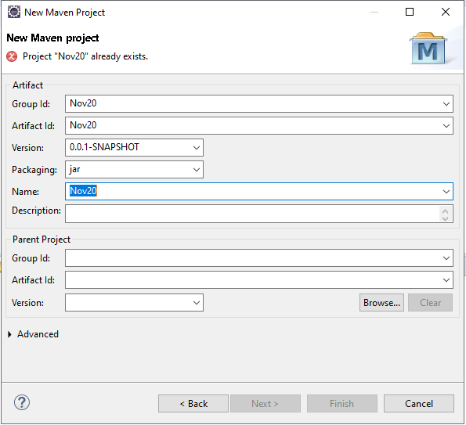

**Now create class and configure pom.xml of the project**

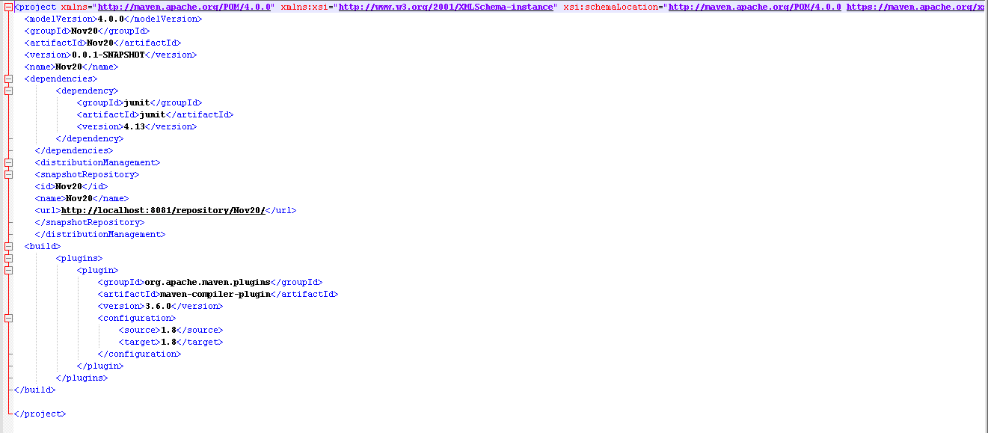

**Create a repository on github to push the project through eclipse**

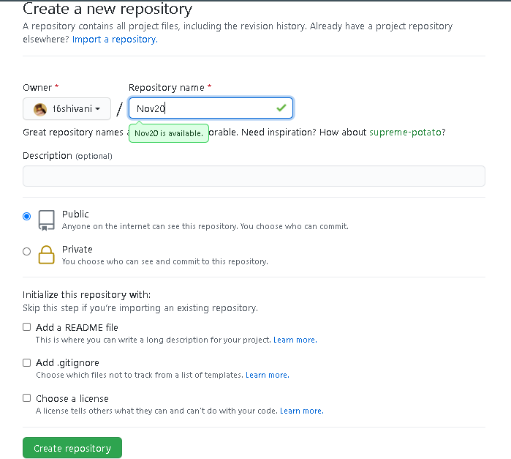

**Now clone the repository in Eclipse IDE through git perspective**

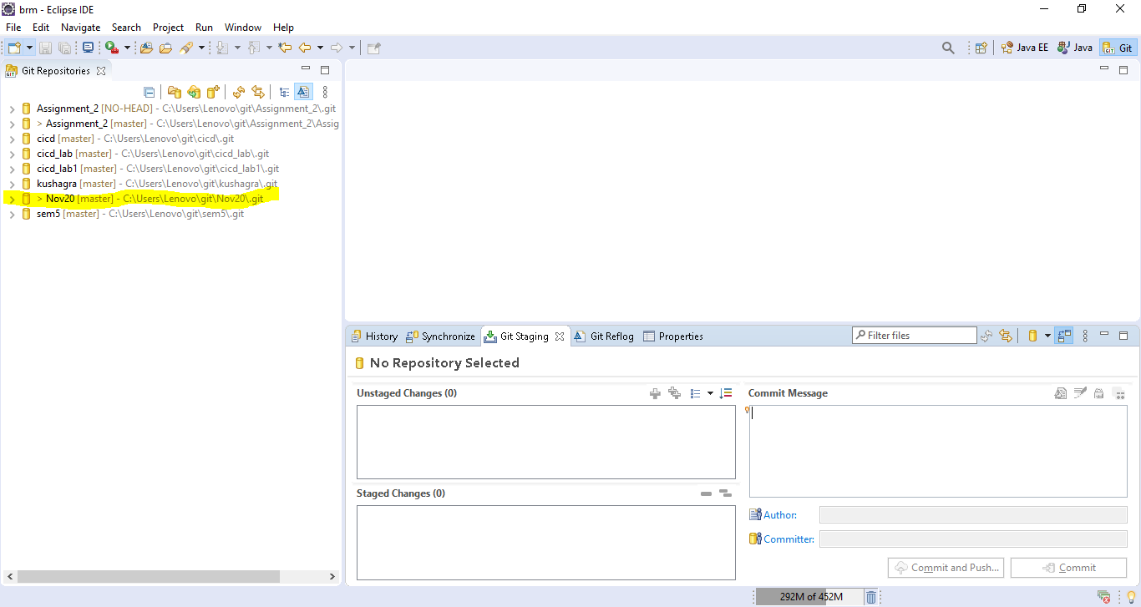

**Now push the changes to github through cloned repository**

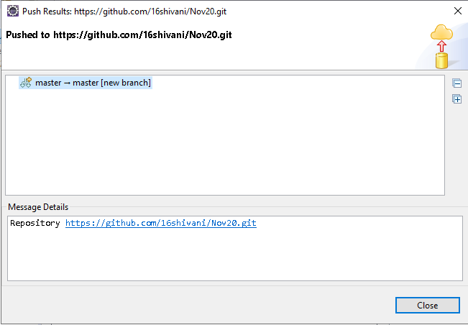

**Add JenkinsFile on the github with following content**

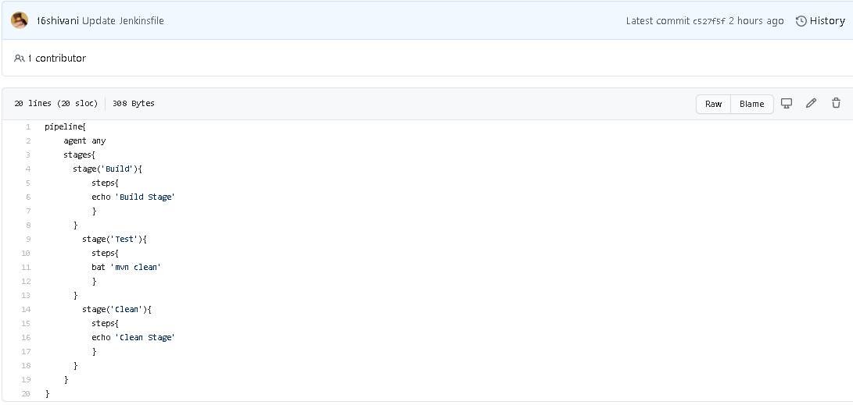

**Now run the command “java –jar Jenkins.war” on your cmd and type “localhost:8080” in the url then the Jenkins dashboard will appear**

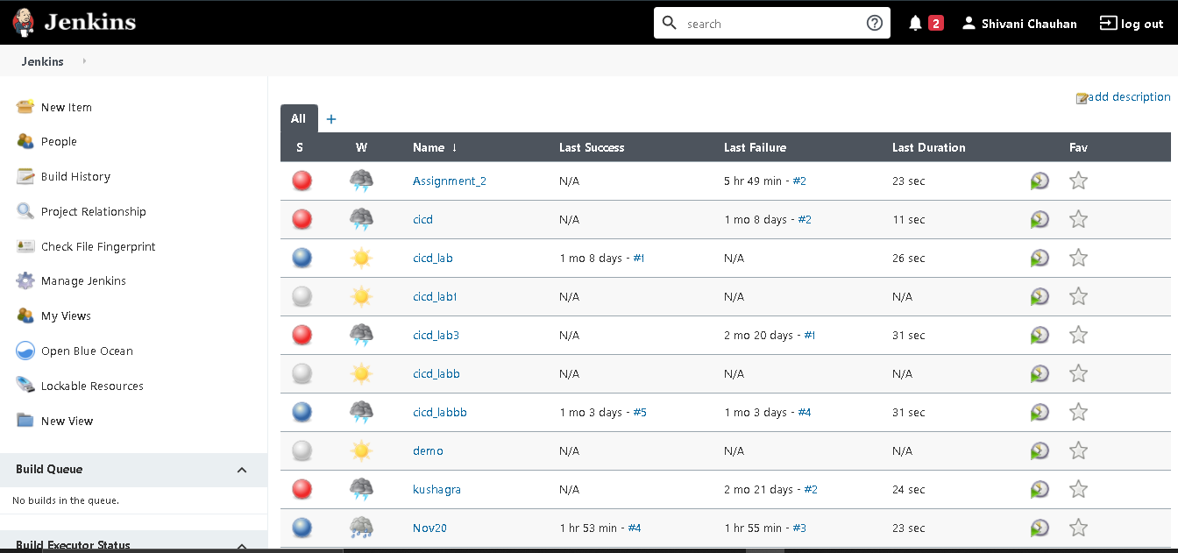

**Now create a pipeline named “Nov20” and configure the pipeline settings and add the github repository url into the url section of settings so that it can use the project from there and use in this pipeline work**

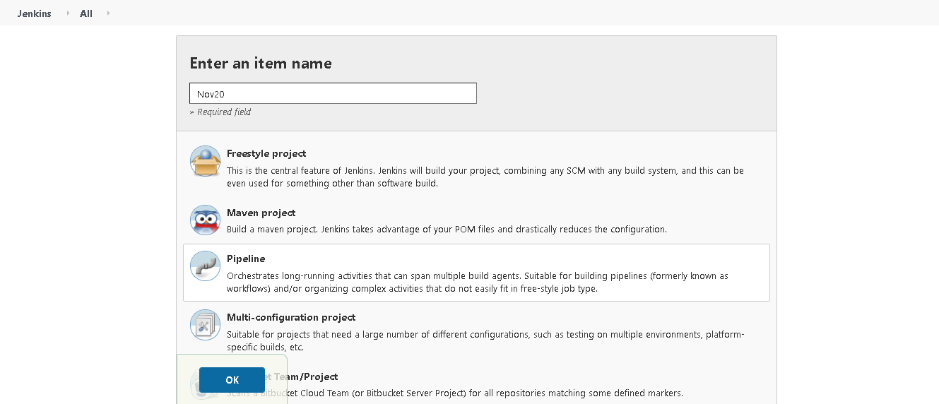

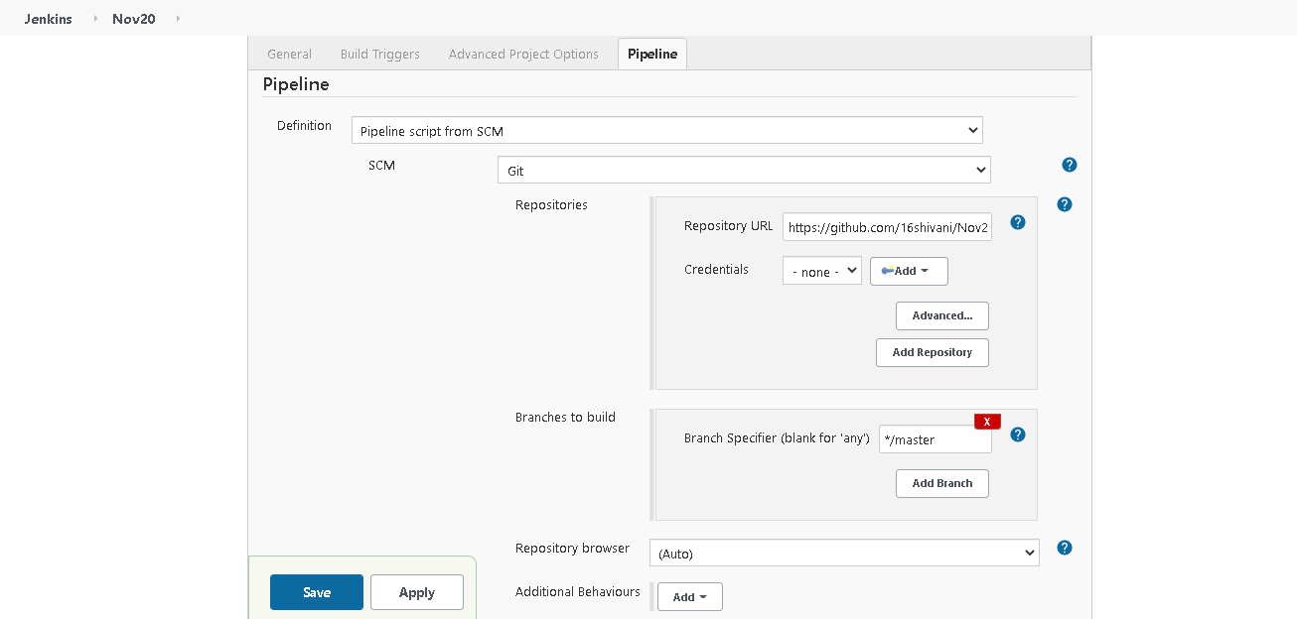

**Now build the pipeline**

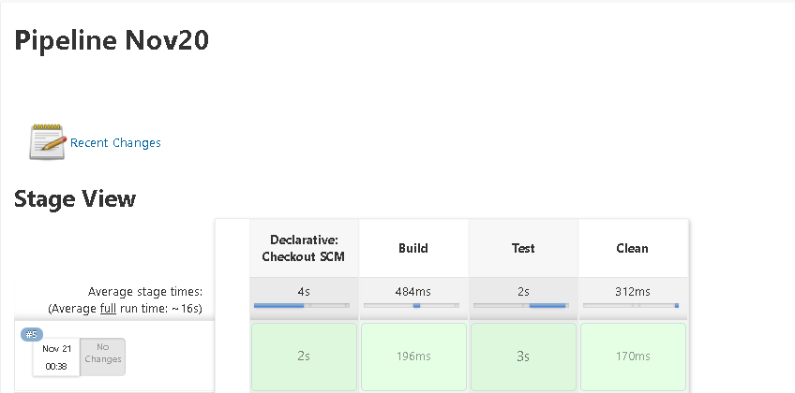

**Now create repository on Nexus named “Nov20”**

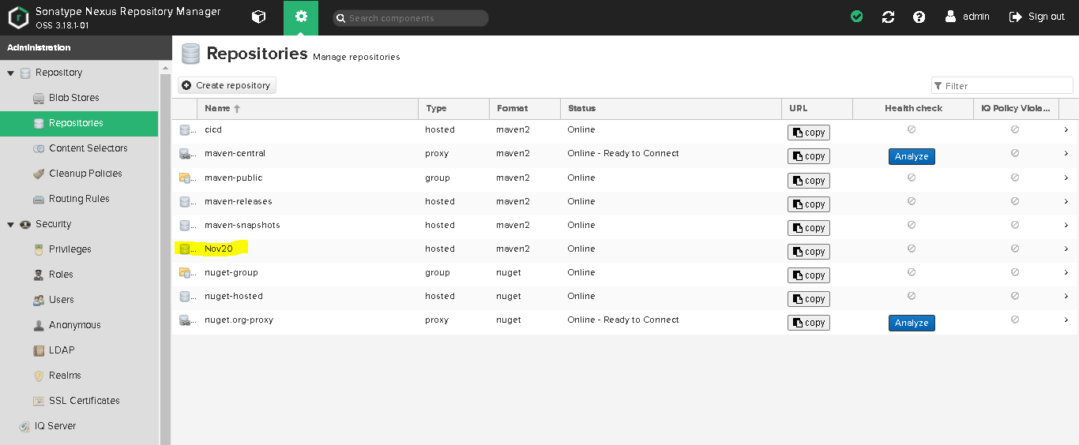

**Configure the pom.xml of project and settings.xml of apache maven and then run the following commands on cmd**

**Mvn clean:**

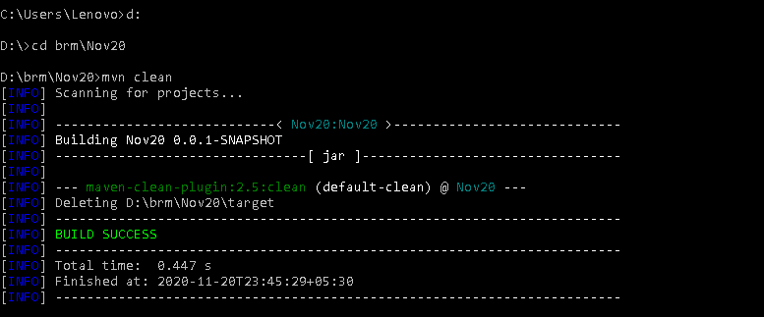

**Mvn install:**

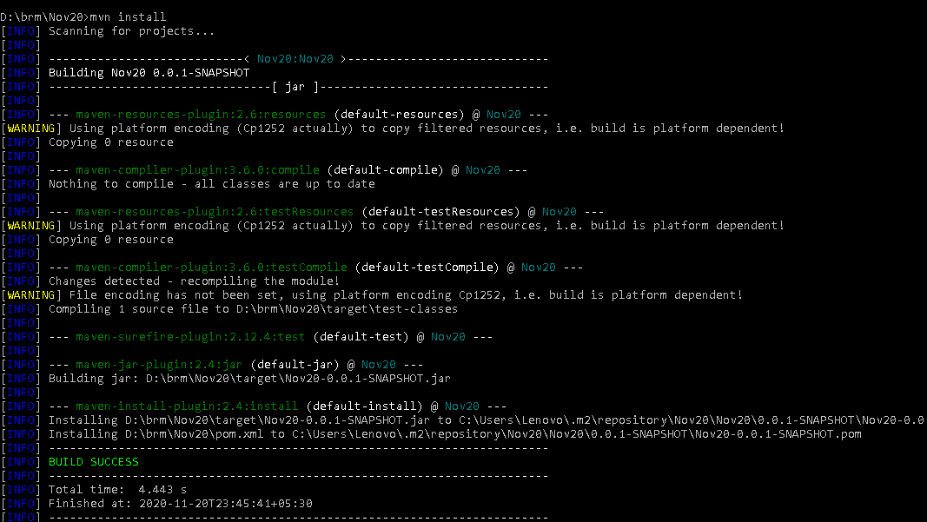

**Mvn deploy:**

